Love this project choice — **deepfake detection** is *serious + high-impact*, and if you design the site right it’ll look **research-grade + startup-ready**, not like a college mini project. Let’s design this cleanly, from **first page → final report**, plus all the **pro-level extras**.

I’ll explain it like a real product flow 👇

**🌐 WEBSITE FLOW (WHAT USER SEES STEP-BY-STEP)**

**1️⃣ Landing Page (First Impression = Trust)**

This page decides whether users believe your model or not.

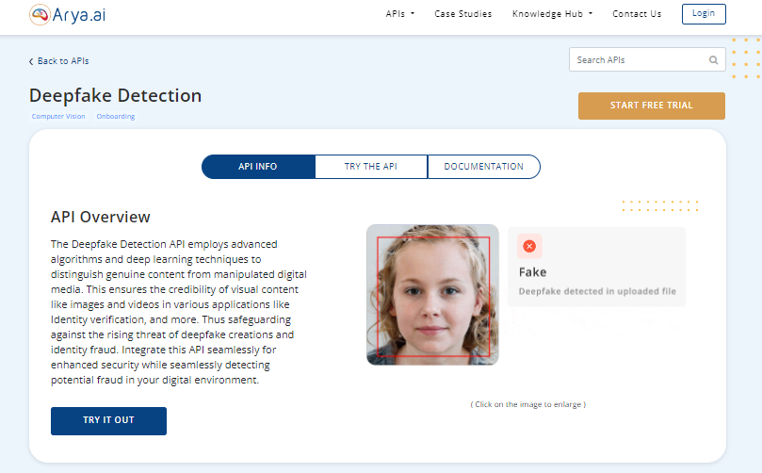

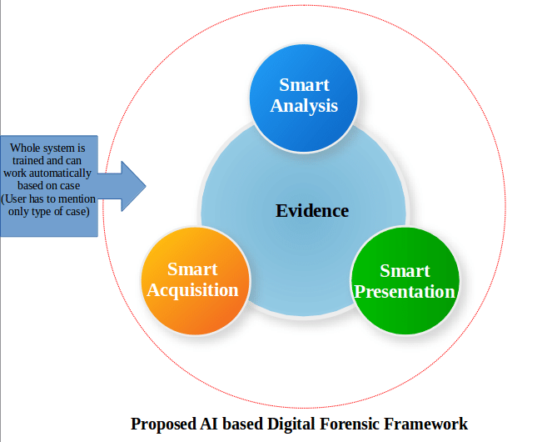

**What user sees:**

* Strong headline  
  **“Detect Deepfakes. Verify Digital Truth.”**
* Short subtext  
  *AI-powered detection for images, videos & audio*
* Primary CTA button  
  👉 **Upload Media**
* Secondary CTA  
  👉 **How it Works**

**Professional sections to add:**

* 🔐 *Privacy First – Files auto-deleted*
* ⚡ *Fast AI Analysis*
* 🎯 *Research-backed Models*
* 🏛 *Use cases (Journalists, Law Enforcement, HR, Social Media)*

**2️⃣ Upload / Input Page (Core Interaction)**

This is where your ML project shines.

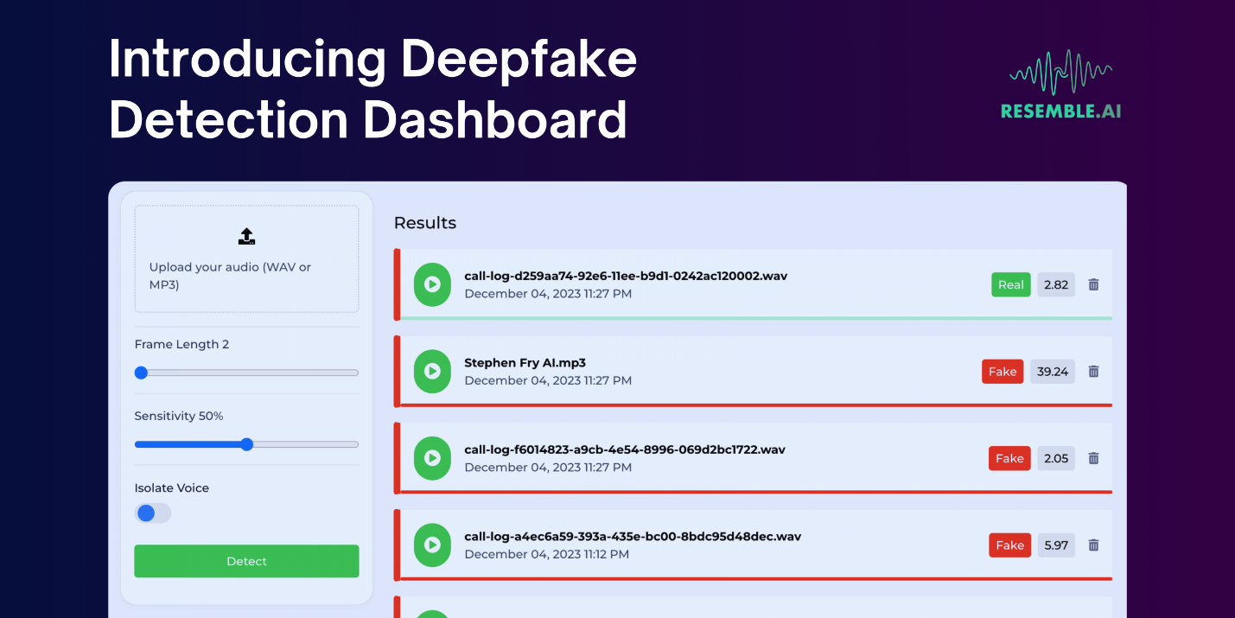

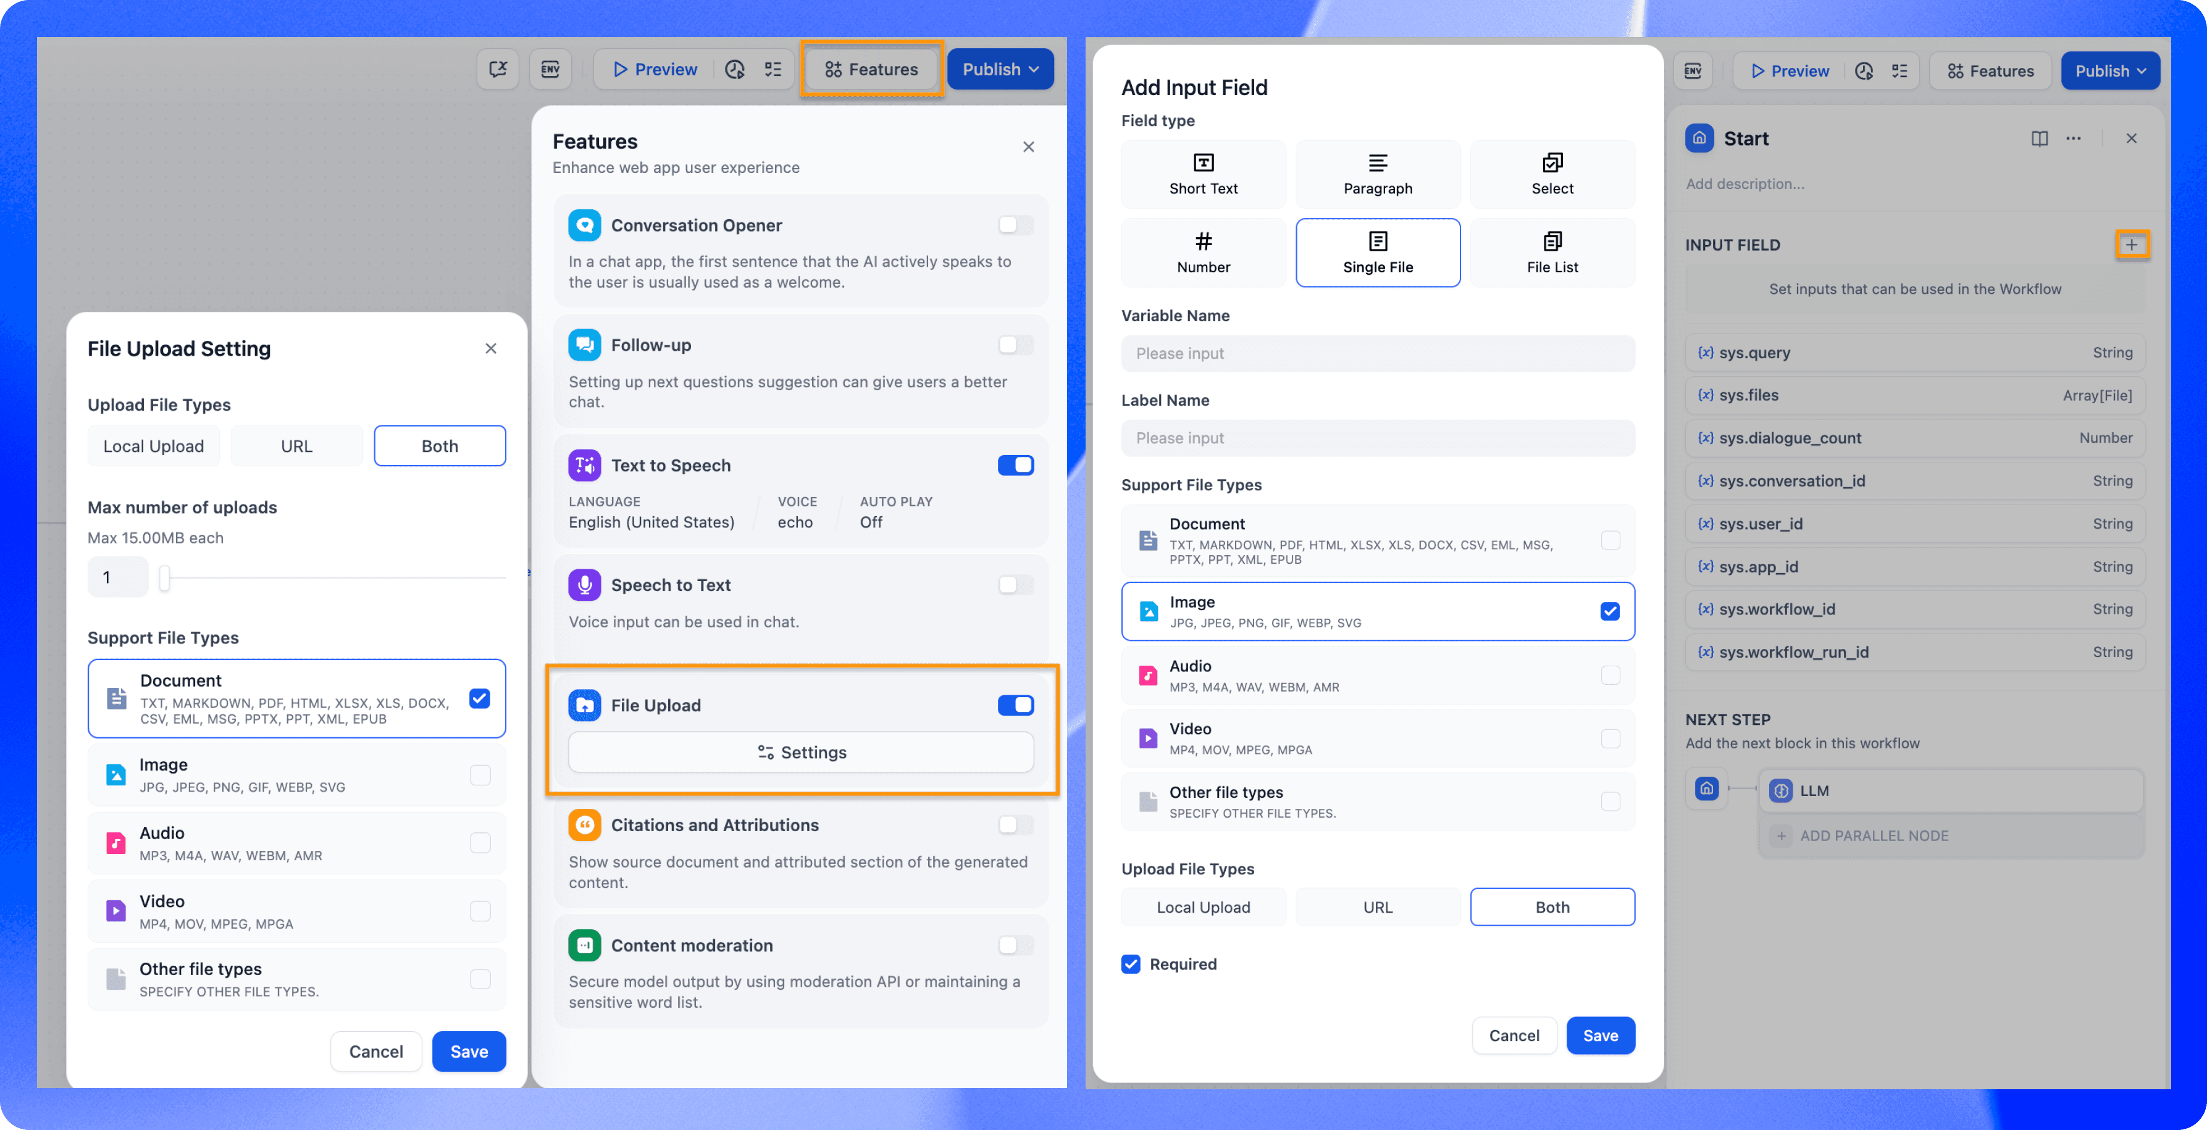

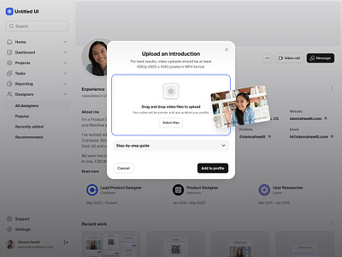

**User options (very important):**

* 📷 **Image Detection**
* 🎥 **Video Detection**
* 🎙 **Audio / Voice Detection**
* 🌐 **URL Detection** (YouTube / Instagram link – optional advanced)

**Upload constraints (professional touch):**

* Max file size (ex: 100MB)
* Supported formats (JPG, PNG, MP4, WAV)
* Drag & Drop UI
* Progress bar during upload

**Extra credibility features:**

* File hash shown (SHA-256)
* “Your file is processed locally & deleted after analysis”

**3️⃣ Analysis Page (Processing State)**

Don’t just show a spinner — this is where most projects look amateur.





**Show steps like:**

* ✔ Extracting frames
* ✔ Facial landmark detection
* ✔ Audio frequency analysis
* ✔ Neural consistency check
* ✔ Model inference

This builds **trust**.

**4️⃣ Result Page (MOST IMPORTANT PAGE)**



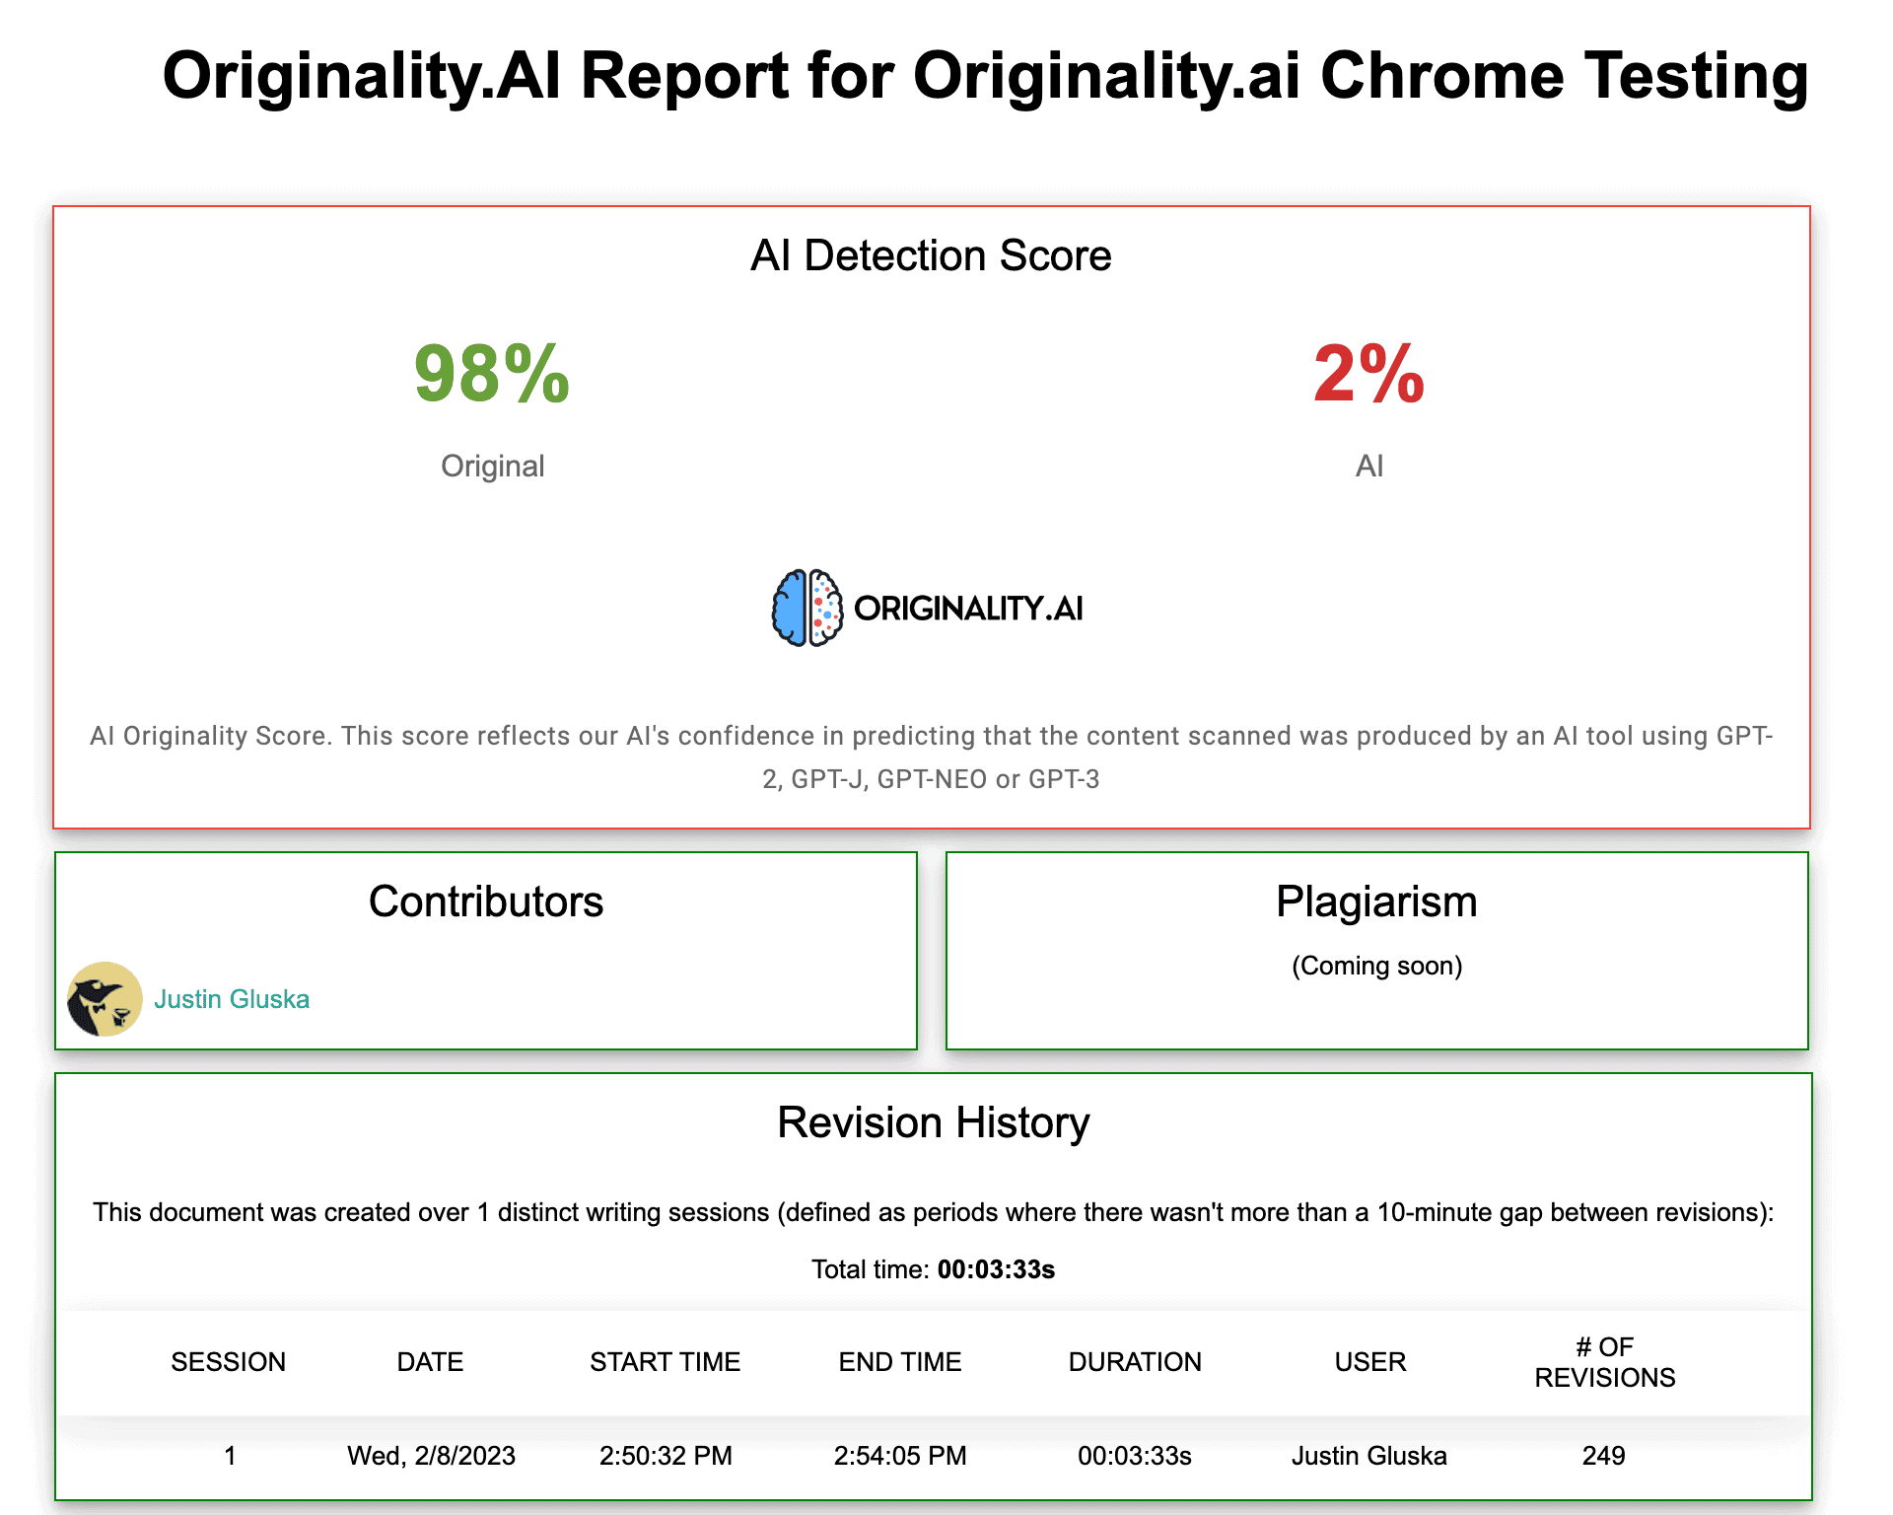

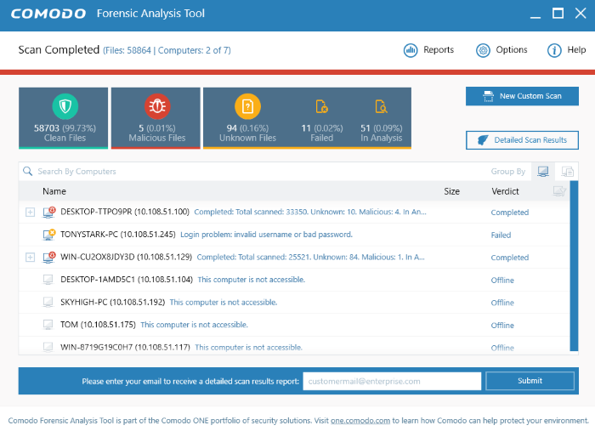

**What user should see:**

**🔍 Final Verdict**

* ✅ **Real** (Green)
* ⚠️ **Suspicious**
* ❌ **Deepfake Detected**

**📊 Confidence Score**

* Example: **87% Likely Deepfake**

**🧠 Model Insights (Professional)**

* Face texture inconsistency
* Eye blink irregularity
* Audio-lip sync mismatch
* GAN artifact patterns

**🖼 Visual Proof**

* Highlight manipulated regions
* Frame-by-frame heatmaps

**📄 Downloadable Report**

* PDF with timestamp
* Hash of file
* Model version
* Verdict summary

**5️⃣ History / Dashboard (Optional but PRO)**

If user logs in.

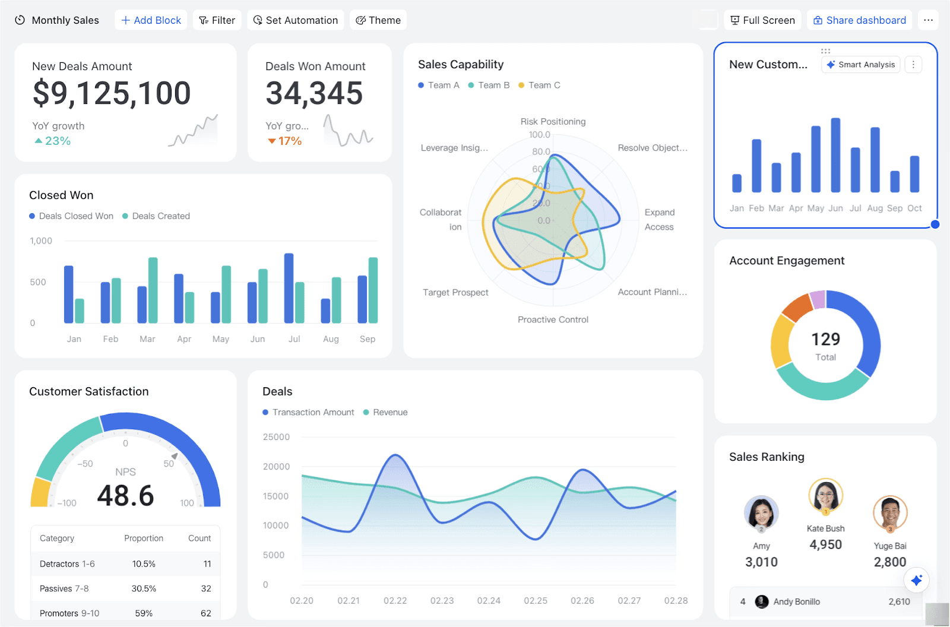

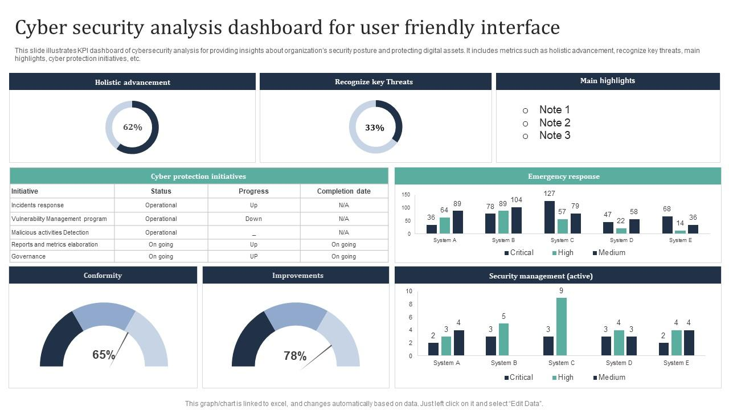

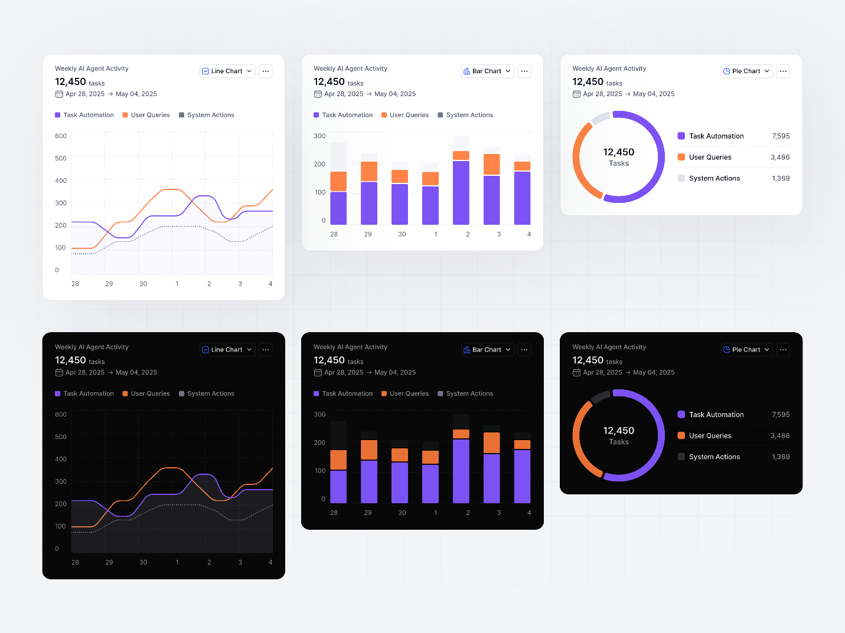

**Dashboard shows:**

* Past scans
* File type
* Result
* Confidence score
* Download report again

**🎯 WHAT TYPE OF CONTENT SHOULD YOUR SITE DETECT?**

| **Content Type** | **Detection Methods** |
| --- | --- |
| Images | GAN artifacts, texture noise |
| Videos | Frame inconsistencies, lip sync |
| Audio | Voice cloning detection |
| Face Swap | Landmark mismatch |
| Lip Sync | Audio-visual mismatch |
| AI Avatars | Unreal facial motion |

👉 If you implement **only Image + Video first**, that’s 100% okay. Quality > quantity.

**⚙️ USER OPTIONS (KEEP IT CLEAN)**

User should get:

* Upload / URL input
* Select detection type
* View detailed result
* Download report
* Delete data manually
* Dark / Light mode

**🏆 EXTRA FEATURES THAT MAKE IT “SUPER PROFESSIONAL”**

**🔐 Trust & Security**

* Privacy policy page
* Data retention statement
* GDPR-style consent checkbox
* File auto-deletion timer

**🧪 Research Credibility**

* “Model Architecture” page
* Dataset sources
* Accuracy metrics
* Limitations (very important for honesty)

**📚 Explainability**

* “Why was this flagged?”
* Model confidence explanation
* Known false positives

**🧩 Tech Stack Page (Recruiters LOVE THIS)**

* Frontend: HTML, CSS, JS / React
* Backend: Flask / Django / FastAPI
* Model: CNN / LSTM / Transformer
* Dataset: FaceForensics++, DFDC

**📈 Performance Stats**

* Avg processing time
* Model accuracy
* False positive rate

**🧑‍💼 About / Contact**

* Your name + role
* GitHub link
* Research paper (if any)

**🎨 DESIGN RULES (IMPORTANT)**

To look professional:

* Dark theme + accent color (purple/blue)
* Minimal text
* No emojis on main pages
* Clean typography (Inter / Poppins)
* Consistent spacing
* Real-time feedback animations

**🚀 FINAL ADVICE (VERY IMPORTANT)**

If you do **just these 5 pages well**:

1. Landing
2. Upload
3. Analysis
4. Result
5. About / Tech

👉 Your project will look **internship-ready + hackathon-ready + portfolio-ready**.

If you want next:

* 🔹 **Exact page wireframe (layout blocks)**
* 🔹 **Database schema**
* 🔹 **Flask/FastAPI backend flow**
* 🔹 **How to explain this project in interviews**

Just tell me what you want next 💪